

CHAROTAR UNIVERSITY OF SCIENCE AND TECHNOLOGY

FACULTY OF TECHNOLOGY AND ENGINEERING

B. TECH (IT/CE/CSE/AIML)

Practical : 13
Practical Statement:
• Add an AI-powered feature to the Task Management application using
the OpenAI API or Gemini API.
• The feature must serve a meaningful purpose for example, auto-
generating a task description, suggesting a priority level, or proposing a
deadline based on the task title.
• The API key must be stored and used only on the backend (.env),
never exposed to the frontend.
• Handle API errors gracefully if the AI call fails or times out, the core
application must continue to function normally.
• Display the AI-generated response meaningfully in the React UI, not as
raw JSON.
Screenshots (Supplementary Problems are also implemented):

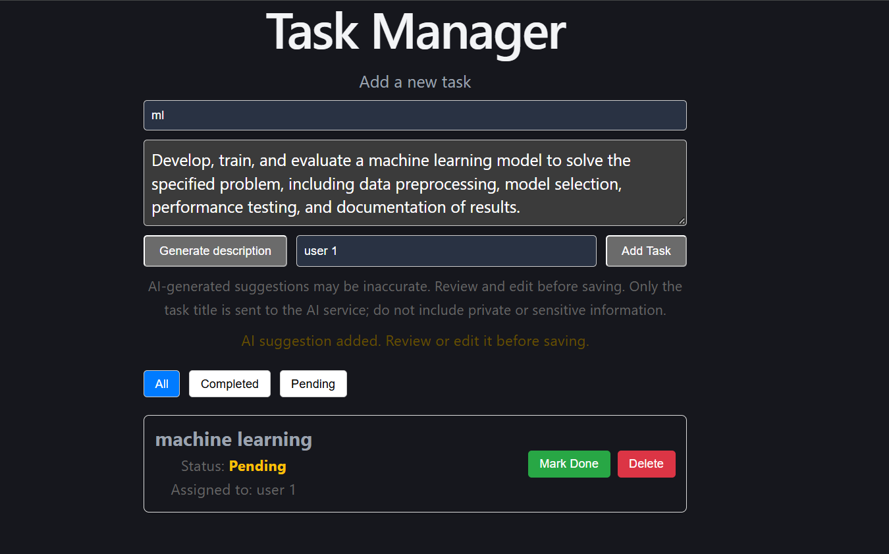
AI suggestion added

Key Questions / Analysis:
1. Why must the AI API key be called from the backend rather than directly from the React frontend?
Answer : The AI API key must be stored and used in the backend because frontend code is visible to users through browser developer tools, making exposed API keys vulnerable to theft and misuse. The backend keeps the key secure using environment variables and sends requests to the AI service on behalf of the frontend. This protects credentials, helps control API usage, and allows the developer to validate requests before sending them to the AI service.
2. What does graceful degradation mean in this context, and why does it matter for a feature that depends on a third-party service outside your control?
Answer : Graceful degradation means that an application continues to provide its core functionality even when an additional feature or external service fails. For example, if an AI service becomes unavailable, the task management application should still allow users to create, update, view, and delete tasks while displaying an appropriate message that the AI feature is temporarily unavailable. This improves reliability and user experience because third-party services may experience network issues, API limits, or unexpected downtime.
3. What are the privacy and governance implications of sending task data to an external AI API, and what kind of data should never be sent this way?
Answer : Sending task data to an external AI API may expose sensitive information to a third-party provider, creating privacy, security, compliance, and data-governance risks. Developers should review the provider's data-retention policies, obtain appropriate consent, minimize the data shared, and follow applicable privacy regulations. Passwords, API keys, authentication tokens, financial account details, confidential business information, and personally identifiable or sensitive personal data should never be sent unless there is a specifically authorized, legally compliant, and appropriately secured process for handling them.

Key Skills Addressed:
• Calling an external AI API securely from a Node/Express backend
• Designing a feature that degrades gracefully when a third-party
dependency fails
• Parsing and displaying AI-generated content meaningfully in a React UI
• Reasoning about ethical, privacy, and governance implications of AI integration
Learning Outcome:
- Students will be able to securely integrate a third-party AI API into a full-
stack application, handle failures gracefully, and articulate the responsible-AI considerations involved.

Github Repo Link: https://github.com/Gauravk6531/Advanced-Web-Development-Frameworks/tree/Practical_13

